Prompt
The Commercial Banking Corporation (hereafter the “Bank”), acting by and through its department of Revolving Lines of Credit is seeking proposals for banking services. The scope of services includes the following:
- Creation of a scorecard, to be used for evaluating all retail credit applications (credit facilities, revolving lines of credit, etc.)
- Creation of a distribution to associate score buckets (preferably deciles) with default rate.
- Regulatory compliance (FDIC) requires the usage of reject inference. The reject inference technique is at the discretion of the Responder but it should be clearly stated in the report.
- The Bank’s analysts suggest a training / validation mix of 70% / 30%; the Bank is open to other proposals as long as they are clearly stated and supported.
- General guidelines for final cutoff points: Respondents to this RFP can define either:
  - Single cutoff points (e.g. Reject if Score ≤ 400; Accept if Score ≥ 401) or
  - Cutoff ranges (e.g. Reject if Score ≤ 400; Accept if Score ≥ 450; Further evaluation for scores within 401 to 449)
  - The above scores are just used for example, nothing else
- Cutoff points should be identified with the purpose of:
  - Maintaining the existing acceptance rate (75%) while minimizing event (default) rates and/or
  - Maintaining the current event rate (3.23%) while maximizing the acceptance rate
  - Maximizing the profitability of the department, considering the following:
    - Expected revenue of accepted good customers: $2,000
    - Expected cost of accepted bad customers: $52,000
- The Bank assigns a score of 500 to applicants with odds-ratio 20:1.
- Doubling the odds is associated with a change of 50 points in the scorecard.Prompt Here

Breakdown
- Finalized Code
  - Import packages
  - Read in accepted customers
  - Train test split of accepted customers data
  - Ensure that target and sample weights are in correct format
  - Binning and variable selection
  - Fit logistic regression
  - Fit scorecard (params: "pdo": 50, "scorecard_points": 500, "odds": 20)
  - Model evaluation on training data
  - Model evaluation on test data
  - Score on test set
  - Create deciles and compute PD per decile
  - Combine accepts and rejects

Report

Report is subtab

Code and Plots

Report Here

Banking Services Proposal: Scorecard for Evaluating Retail Credit Applications

Homework Team 4
Lukman Awad, Irvin Carreon, Seamus Flaherty, April Groce, Grayson Nico

February 19, 2026

Table of Contents

Overview 1
Methodology 1
Data Used 1
Data Preprocessing 1
Analysis 2
Initial Scorecard Development and Evaluation 2
Reject Inference 2
Results & Recommendations 2
Final Scorecard Results 2
Scorecard Cutoff Results 3
Conclusion 4

Banking Services Proposal: Scorecard for Evaluating Retail Credit Applications

Overview
The Commercial Banking Corporation’s Department of Revolving Lines of Credit has requested the creation of a scorecard to be used for evaluating all retail credit applications. Our team thus developed a scorecard to meet this need and optimize profitability based on statistical significance. Based on our model, we recommend automatically approving customers above 493, manually reviewing those with a score between 463 to 492, and rejecting those below 463.

Methodology
The following section describes the format and preparation of the data used to produce our initial and final scorecards.

Data Used
Our team developed a scorecard using a dataset of previously accepted applicants and a dataset of previously rejected applicants.

The rejected applicants dataset contains information on applicants who were not approved. This dataset included 1,500 observations and 22 variables.

The accepted applicants dataset contains information on applicants who were approved. The dataset includes 3,000 observations and 24 variables. This dataset shared all of the same variables with the rejected data, with the addition of two variables: "good/bad" classifier as well as the oversample weights. The sample is balanced, with 1,500 “good” applicants (i.e., those who have never been 90 days past due on payment) and 1,500 “bad” applicants (i.e., those who have been 90 days past due on payment at least once). There are no indeterminate cases in this dataset. The original development sample had an actual bad rate of 3.23%, and over-sampling corrected this rate with verified weights.

Data Preprocessing
To prepare for fitting our initial scorecard, we split the accepted applicants data using the Bank’s suggested 70:30 train-test split. We binned variables and performed variable selection using Information Values (IVs), which ranks variables on the basis of their importance. We retained only those variables with an IV between 0.1 and 1.0 to ensure meaningful predictive strength.

Analysis
This section describes the development and evaluation of the initial credit scorecard, the implementation of reject inference, and the performance of the final scorecard.

Initial Scorecard Development and Evaluation
Using the accepted applicant training data, we developed an initial credit scoring model by fitting a logistic regression to the Weight of Evidence (WoE) transformed variables. The WoE transformation standardizes predictors and ensures a more linear relationship with the log-odds of default, making them suitable for logistic regression modeling. We used this model to construct the initial scorecard.

Our initial scorecard had an area under the ROC curve (AUC) of 0.72, indicating a strong ability to distinguish “good” applicants from “bad” applicants. This scorecard had a K-S statistic of 0.33 with an optimal probability cutoff of 0.03, which classifies any applicant with a predicted default probability above 0.03 as a “bad” applicant.

Reject Inference
We implemented reject inference to align with FDIC requirements and create a scorecard that can generalize to the entire credit population. Using our initial scorecard, we calculated predicted probabilities of default for the dataset of rejected applicants. We then classified these rejected applicants as “good” or “bad” using the same 0.03 cutoff from our initial scorecard evaluation.

We combined the 1,500 rejected applicants with the 3000 accepted applicants to remove the bias generated by excluding rejects. After combining both applicant pools, we obtained a split of 67% accepted applicants and 33% rejected applicants. This split differs from the Bank’s current acceptance rate of 75%. To align our distribution with this rate, we reweighted accepted applicants while maintaining the Bank’s current default rate of 3.23%. This approach ensured that the impact of the accepted applicants in our sample would generalize to the 75% of future applicants that the Bank will accept.

The same processes of train-test splitting, variable binning, and fitting the credit scoring model were performed to produce the final scorecard.

Results & Recommendations
In this section, we will discuss the process for determining the final cutoff.

Final Scorecard Results
After incorporating reject inference, the final scorecard achieved an AUC of 0.73, demonstrating strong discriminatory power between good and bad applicants under the expanded modeling framework.

Figure 1 visualizes a decile plot that bins predicted scores from the test dataset into ten equal pieces.

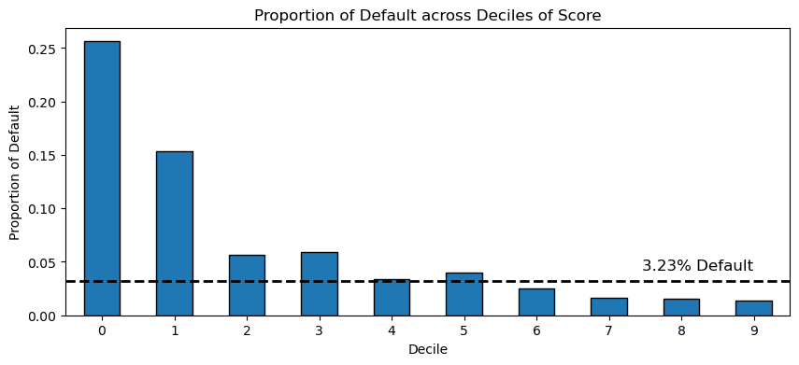
Figure 1: Proportion of Default across Deciles of Score

As shown in Figure 1, the proportion of defaults generally decreases. This trend indicates that our scorecard correctly assigned lower scores to applicants who had higher default probabilities, and higher scores to applicants who had lower default probabilities.

Scorecard Cutoff Results
To determine the optimal cutoff, we evaluated how the credit score cutoff impacts the Bank’s default and acceptance rate. A line graph depicting this relationship is shown in Figure 2.

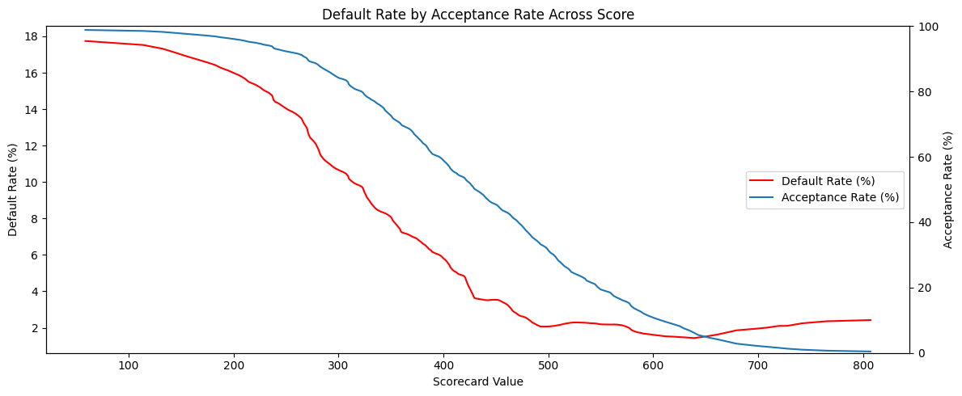
Figure 2: Default Rate by Acceptance Rate Across Score

From Figure 2, our team observed that the default rate decreases steadily as the credit score cutoff increases, which indicates improved borrower quality. Similarly, the acceptance rate also decreases as the credit score cutoff increases. At low score thresholds, almost all applicants are approved, but default rates peak. The converse is seen at higher score thresholds. While Figure 2 identifies the score range where the optimal cutoff lies, it does not take into account the Bank’s profit margins. Figure 3 shows the relationship between the Bank’s profit and acceptance rate.

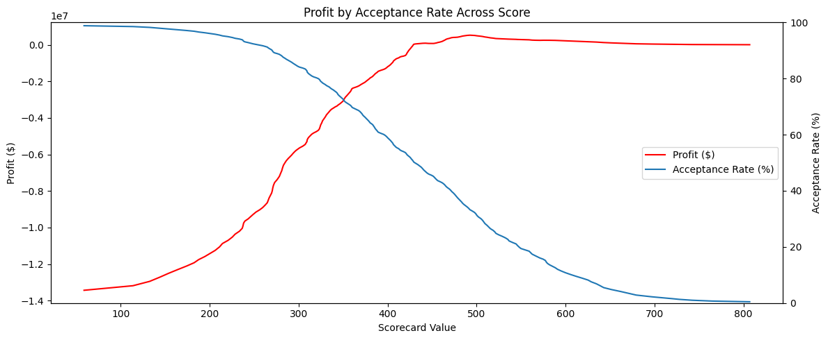
Figure 3: Profit by Acceptance Rate Across Score

The acceptance rate visualized in Figure 3 shows the same pattern from Figure 2. However, the profit curve is mostly increasing, peaking at a credit score of 493. This peak represents the point at which the Bank’s profit is maximized. Scores beyond this peak slowly begin to decrease the Bank’s profit.

Therefore, for evaluating all retail credit applications, we recommend that the Bank automatically accept applicants with credit scores above 493 to optimize profitability. Additionally, we recommend that the Bank reject applicants with scores below 463 to maintain stability of the current default rate. Scores that fall within this range should be reviewed manually to optimize profitability.

Conclusion
This scorecard maintains the Bank’s current acceptance rate of 75% while maximizing profit. Our final model is not only more representative of the applicant population, which improves accuracy and reduces bias, but also seems to discriminate well with an AUC of 0.73 and a relatively decreasing decile chart.

Overall, based on the Bank’s revenue, cost requirements, and the tradeoff between acceptance and default rates, we recommend a range where customers above 493 are automatically accepted while those below 463 are automatically rejected. For scores between 463 to 492, we recommend manually reviewing those applications to better optimize profitability.

HW Report Checklist

Homework Report Checklist - Team 4

As instructed by Hiya and Dr. Egan Warren, the team member(s) responsible for checking each item should enter their initials in the field next to each question. All items should be addressed before submitting the assignment with the initialed checklist attached.

Sections & Structure

Overview
AG | Is the overview concise?
AG | Does it provide context about the business problem? <Content>
AG | Does it briefly address your team’s work, quantifiable results, and recommendations? <Action>
AG | Does it offer audience-centered reasons for recommendations? <Context>

Body Sections
AG | Does the report body include information on methods, analysis, quantifiable results, and  recommendations?
AG | Is content grouped into appropriate sections (methodology, analysis, results, recommendations)?

Conclusion
AG | Does the report have a conclusion?
AG | Does the conclusion sum up the report and emphasize relevant takeaways?

Structure
AG | Does each major section have a heading?
AG | Are sections, subsections, and paragraphs organized logically for easy navigation?

Visuals

Introduction, Discussion, and Captions
LA | Is each visual introduced in the text before it appears?
LA | Is each visual close to where it is introduced?
LA | Does each visual include a title with the following information: type (table or figure), number, and a  descriptive caption?
LA | Is each visual discussed and interpreted in the text?
LA | Are figures and tables numbered separately?
LA | Are table captions above the table? Are figure captions below the figure?

Visual Design
LA | Do figures/tables use audience-friendly labels rather than variable names?
LA | Are the visuals easy to interpret?
LA | Are the visuals appropriately sized?
LA | Do tables appear on one page (not split between 2 pages)?
LA | Are legends and axis labels included for figures?
LA | Are numbers in tables right aligned?
LA | Are the visuals designed well (ex: re-created in Word or Excel, not blurry or stretched,…)?

Document Design

Title Page Design
LA | Does it include a descriptive title?
LA | Does it state the team name, team members’ names, and the submission date?

Table of Contents Design
LA | Does it list all the major sections of the report with corresponding page numbers?
LA | Do the page numbers and sections in the Table of Contents match the report?

Document Design for Entire Report
SJF | Is a standard typeface (Calibri, Arial, etc.) used?
SJF | Is the size of the body text between 10-12 pt.?
SJF | Are headings and subheadings used to organize information?
SJF | Are distinctive text styles (bold, italic, etc.) used to distinguish between heading levels?
SJF | Are text styles for headings used consistently (ex: all level-one headings are bold)?
SJF | Are all paragraphs an appropriate length (fewer than 12 lines)?
SJF | Is white space used to indicate paragraph breaks?
SJF | Are bullet lists used for a series of items and numbered lists to show a hierarchy?

Writing Style and Mechanics

Spelling and Capitalization
IC | Are spelling errors located and corrected?
IC | Is spelling consistent throughout (no switching between acceptable spellings)?
IC | Is capitalization used appropriately (proper nouns, etc.)?
IC | Is capitalization of words consistent throughout the report?

Grammar and Punctuation
GN | Are verb tenses used appropriately?
GN | Are marks of punctuation used appropriately?
GN | Is subject-verb agreement used in every sentence?
GN | Is the grammar checker updated and are underlined grammar issues addressed?

Writing Style
IC | Are all sentences in the report easy for your audience to understand quickly?
IC | Are most sentences written in active voice?
IC | Are idioms and vague words eliminated from the report?
IC | Are acronyms introduced before being used?
IC | Are well-written topic sentences included at the beginning of each paragraph?
IC | Are lists parallel?
IC | Is the appropriate point of view used when addressing your audience or describing team actions?

